Development and Analysis of Local Frequency Assignment Algorithms
Péter Biró–Krisztina Lója– Márton Sütő
Budapest University of Technology and Economics (BUTE)
Mathematician undergraduates
Introduction
Using ever smaller cells is a general tendency in the development of mobile, cellular networks. It is needed because of the employment of higher and higher frequencies on the one hand and due to the increasing capacity demands on the other. The propagation of radio waves of ever higher frequencies becomes similar to the propagation of light, where radio waves are easily absorbed by the various objects and obstacles. In such situations a direct contact is usually needed between the transceiver and the receiver for the communication, which call for the deployment of smaller and smaller cells. Using smaller and smaller cells is also a way of increasing capacity. In such a case, the capacity of the same base station is available in a smaller area, which enables to serve a higher user density.
Such micro- and pico cell environments can be imagined in densely populated or business districts, and as indoor mobile systems. Independently of the specific environment and system, the configuration and cell planning of such a network and the coordination of the use of the frequency spectrum become more and more difficult because of the great number of cells. On the other hand, a part of these systems, typically indoor systems, must be deployable by the user (for example the contemporary Wireless LAN systems), where the user cannot be expected to do detailed cell and spectrum planning or carry out any other complicated configuration operation. Instead, we require the system to adjust the necessary operation parameters by itself through auto configuration.
One of the most important steps is the assignment of frequencies, such that adjacent base stations use different frequencies, thus the interference between cells can be avoided. This is solved in the cellular networks of today usually with off-line frequency planning prior to the deployment of the network.
In this paper we are dealing with the problem of automatic frequency configuration, where the task is to solve the frequency assignment problem in a distributed on-line way. We focus on the development and analysis of such algorithms, which are running in each base station and which can determine the frequency of the transceivers such that no interference occurs among adjacent base stations. A very important difference between the conventional cell planning and these algorithms is that these algorithms work on-line and typically using only local information, while off-line cell planning can take the whole network into consideration and can rely on time-consuming, difficult algorithms.

Mathematical model
The mathematical model of the problem is given by the so-called interference graph, which is defined below. The vertices of the graph correspond to the base stations, and there is an edge between two points if and only if the corresponding transceivers are closer to each other than a given critical distance (d); d≥2R, where R is the range of the base stations.

Figure 1 Derivation of the interference graph

Our task is to colour the vertices of the graph so that adjacent vertices are coloured differently. Furthermore, the colouring algorithm should be realized in a distributed way so that base stations should choose frequencies only by using local information or by minimal exchange of information with their neighbours. We assume that base stations can measure the level of interference on all the possible frequencies and can perceive, which frequencies are free and which are in use in their neighbourhood. This gives the initial local information that is available in all cases now. It is an interesting question, how the performance of the algorithms can be improved with further exchange of information between the base stations.
One of the most important measures of the performance of the algorithms is the number of used colours and the number of the so-called blocked cases, when the algorithm cannot colour the graph with the given bound on number of colours. We will use these measures later for assessing the algorithms.
We studied the performance of the algorithms in the cases of essentially two types of graphs. We tested graphs with given chromatic number, where we know exactly how many mistakes the algorithm makes, that is, how many more colours it uses, than the minimum needed. We investigated also graphs that arise by a typical positioning of base stations. In the latter case we took two characteristics into account. The nearly uniform covering of the given area is the first, and the second is the randomization due to the ad hoc deployment.

The theoretical bounds of colouring
Deciding whether a graph is k-colourable (in the case of k≥3 constant) is one of the known NP-complete problems. The optimal colouring of a graph is also NP-hard if we know its chromatic number (χ(G)), the smallest number of colours possible in a proper vertex colouring of G (a colouring is proper if adjacent vertices get different colours). This means, that we cannot give a polynomial algorithm that solves the problem optimally in general – although one of the most famous conjectures of computer science, P≠NP is not proved. Moreover, according to the theorem of Johnson [5] we cannot guarantee the colourability within a multiplicative error, since if there is a polynomial graph colouring algorithm that uses at most cχ(G) colours (where c is a positive constant) to colour any given graph G, then there exists a polynomial algorithm to determine χ(G).
However, there are some classes of graphs with positive theorems. One of the most famous of these is the class of planar graphs, where according to the well-known 4-colour theorem proved by Appel and Haken, every graph can be coloured with at most 4 colours. The theorem of Borodin [5] is also interesting for us, it states, that every graph, that can be drawn in the plane so that none of the edges is intersected by more than one, is always 6-colourable.
The case investigated by us is unfortunately more general because of the disordered base stations and so, in the lack of restricting conditions a polynomial algorithm that would always solve the problem optimally is not expected. It is a general experience, that exponential algorithms can handle the problems like this with fewer than about 20 points, but their run time increase extremely rapidly over that. For these reasons, our aim was limited to find polynomial algorithms, which approach the optimal solution hypothetically well. According to this, the run time of our algorithms can be measured only in seconds.

The description of the algorithms
We grouped the single colouring algorithms by three main points of view. The first is the sequence in which we colour the vertices (called sweeping), the second is the strategy of choosing colours and the third is the option of an improvement procedure. We observed in the course of the simulations that the performance of a colouring algorithm depends basically on the sequence in which it colours the vertices. The way of choosing colours and the use of a possible improving procedure has a smaller effect on the performance, though its role is not negligible.

The sequence of the points: In addition to the random order we studied three basic ways of sweeping for which it is necessary to know the whole graph, than we developed four ways of going over the vertices which meet the requirements of locality so they are proper solving methods of the task we set.
  - Random order: We take one point after the other in a random order. This corresponds practically to the case when we turn on the base stations at random without any prior planning. A subject of our paper is just demonstrating how much waste this causes considering the number of used colours.
  - Sweeping with deletion: We delete the points with the smallest degree in turn from the graph and meanwhile we give them serial numbers backwards. The point that remains finally will be coloured first. We will see that in the class of interference graphs this procedure proved to be highly efficient.
  - Sweeping according to degrees: The algorithm numbers the points in a decreasing order according to degrees, so it colours the one with the highest degree first and the one with the smallest at last.
  - Global sweeping: Differently from the foregoing it determines the sequence of the vertices dynamically and takes into consideration which points and how they are already coloured. We colour that point first whose neighbours used up the most colours, so which has the least possibilities to choose from. The degree of the points decides only secondly.
  - Breadth first sweeping: According to the previous procedure, but it chooses a new point only from the local environment (from the neighbours) in a directed breadth first sequence.
  - Depth first sweeping: In the same way as the previous but it uses depth first sequence.
  - Local sweeping according to degrees: We number every point whose degree is more than the degree of its neighbours, than we repeat this procedure on the remaining points, so we get an order of the vertices.
  - Local sweeping with deletion: We number backwards every point which has a smaller degree than its neighbours, and than we delete them from the graph. We continue the previous procedure on the remaining graph until we run out of points.
In the following figures the colouring according to two different orders of vertices can be seen.

Figure 2 Breadth first sweeping Figure 3 Sweeping with deletion

Choosing colours: In the course of the tests we tried out several ways of choosing colours and we kept two of them, which led to the best results according to the most efficient sweepings.
- Greedy colouring: This is the simplest way of determining the colour of a point (the frequency of a base station) nevertheless it is a relatively efficient and therefore an often used procedure, during which the new points choose always the first available colour (the first colour not used by the neighbours) from the a priori numbered colours. Its disadvantage is that the way of taking the points one by one (the sweeping) has a great influence on the efficiency of the algorithm. There is always a sequence of the vertices, which leads to an optimal colouring (using χ(G) colours). The research of the worst case has a wide bibliography. The largest integer k for which a graph G has a greedy colouring using exactly k colours is called the Grundy number of G (Γ(G)). Instead of theoretical results let us consider a special bipartite graph as an example, where the ratio of the number of used colours and the chromatic number may reach n/4 (where n is the number of vertices of the graph).
.

χ(G)=2 Γ(G)=n/2
Figure 4 The optimal and the worst colouring in the case of these special bipartite graphs
This ratio is maximal according to the theorem of Lovász, Saks, Trotter [6], so this example is extreme from this point of view. Christen and Selkow [3] showed more examples on the maximum of the Γ(G)/χ(G) ratio and the extreme values of other graph colouring parameters.
- Clever colouring: It chooses that available colour which is most used by the neighbours of its neighbours, and secondly the one with the smallest index. The main point of this idea is that we try to reuse the already used colours as often as possible. The technical condition of the clever colouring is that the base stations must communicate with each other.
Improvement: If the colourating of the actual vertex needs the use of a new colour (when the neighbours of this vertex already use all of the colours used before) then a returning procedure tries to correct. Improvement is possible if there is a vertex among the neighbours in whose colour class every vertex can get another colour. In that case the actual vertex gets their former colour and these get another one, that way we do not have to use a new colour. In figure 5 we can see that vertex B cannot get a colour already used (we assume that there are only four colours available). Then with the improving procedure the vertex A gets another colour unused by its neighbours, which makes the colouration of B possible.
A
B
A
B

Figure 5 Example for the improving procedure

Results of the tests on the different classes of graphs
According to the three different points of view mentioned above, we prepared every possible combination of the algorithms (2*8*2=32 pieces of algorithms), then we ran them on a great number of graphs belonging to each class and ranked them on the basis of average colour usage, and than drew the conclusions on the efficiency of the algorithms. First we used simple random graphs, than graphs with given chromatic number. We generated than interference graphs which are closer to the real problem, and we analyzed the algorithms on these.

Random graphs:

Random graph: It is generated after giving the number of vertices and the probability of existence of an edge between two vertices.
Graph with given chromatic number: First we choose a number k (k is a positive integer) to be the chromatic number.
Generating these graphs consist of separating the vertices of a random graph into k sets which would be the colour classes. We delete the edges running between the different classes, and then we take one vertex from each class and make a complete graph by adding all possible edges between them. That way the chromatic number will surely be k.
The results of the tests are similar on these two classes of graphs, but the differences between the algorithms are more important on the chromatic class. Let us see an example: we ran the 32 algorithms on 1000 5-chromatic graphs while the number of vertices moves from 20 to 29. The values in table 1 give the number of cases, when the graph was optimally coloured. We can also see, how many times the improving procedure was used.

Number of optimal colourings | Random |  | Deleting |  | Degree |  | Global
Number of optimal colourings | Gr. | Cl. | Gr. | Cl. | Gr. | Cl. | Gr. | Cl.
Simple | 230 | 292 | 709 | 773 | 621 | 691 | 899 | 910
Improving | 663 | 663 | 878 | 889 | 827 | 903 | 924 | 927
Number of improve-ments | 1921 | 1645 | 311 | 234 | 704 | 590 | 46 | 38

Number of optimal colourings | Breadth |  | Depth |  | Deglocal |  | Dellocal
Number of optimal colourings | Gr. | Cl. | Gr. | Cl. | Gr. | Cl. | Gr. | Cl.
Simple | 497 | 780 | 787 | 849 | 621 | 667 | 542 | 663
Improving | 818 | 856 | 873 | 910 | 804 | 815 | 764 | 829
Number of improve-ments | 543 | 170 | 156 | 107 | 702 | 616 | 698 | 526
Table 1 Results of the tests on the class of graphs with known chromatic number
Here Gr. denotes the greedy colouring, Cl. denotes the clever colouring, Deglocal is the local algorithm with sweeping according to degrees and Dellocal is the local one with sweeping with deletions.
If we know the whole graph, the best algorithm is the „global clever improving”. In the local case it is the „depth clever improving”. The clever colouring is always better than the greedy; the role of improving is only important at the sweepings leading to algorithms with less efficiency.

Interference graphs

The most important properties of interference graphs are randomness and a good covering of the plane. We generated 5 classes of interference graphs from the completely inordinate case to the regular triangle lattice, which leads to an ideal covering of the plane.
- Uniform distribution: We spread the vertices on the plane with uniform distribution.
- Altered uniform distribution with an eventual removing of some vertices: For a more uniform covering of the plane, if a vertex falls too close to another vertex, we remove it with a probability decreasing as the distance from the other vertex grows.
- Square lattice graph: We put one vertex in each cell of the lattice with the same probability independently of one another. The covering is better but disorder is still present.
- Hexagon-lattice graph: We spread the vertices similarly to the previous graph, but the cells are now hexagons.
- Regular triangle-lattice graph: The base stations get in the middle of the hexagon-cells, so we get a regular triangle-lattice. This case is interesting, because the number of colours needed depends only on the ratio of the side of a hexagon and the critical distance.

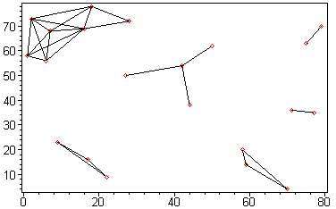
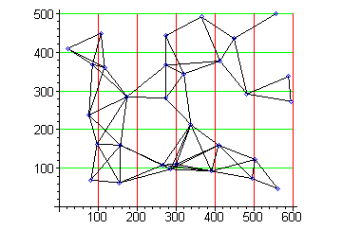
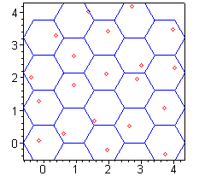
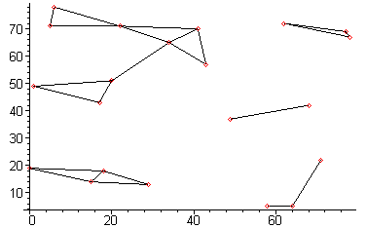
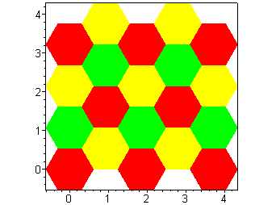
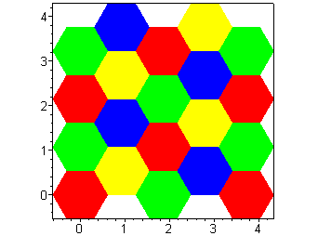
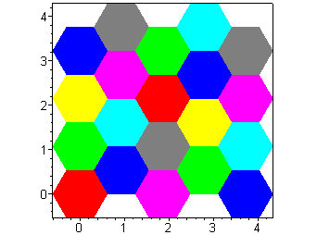
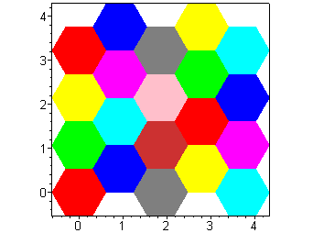
Figure 6: Uniform and altered uniform distribution Figure 7: Square and hexagon lattice graph

1) 2c ≤ d < 3C 2) 3C ≤d < 4c 3) 4c ≤d < K 4) K ≤ d < 6c
Figure 8: The optimal colouring of the regular triangle lattice graph with the variation of the critical distance, (d).
(c= the half of the height of the hexagons, C= the length of the side of the hexagon, $K=\sqrt{(4\text{.}5C)^{2}+c^{2}}$)

On figure 9 we can see the number of colours needed on 1000 graphs while the critical distance grows uniformly from 2c to 6c, so d moves in the four intervals analyzed in figure 8 which are shown by the vertical lines. We can also see that the algorithm with the sweeping with deletion always coloured the regular triangle lattice graphs of 20 vertices optimally, while with the random order the optimum was reached only a few times. That is why we can see uniform values in each interval in the case of the sweeping with deleting and values with dispersion in the other case. The horizontal line shows that the first algorithm does not use more then 9 colours even when the critical distance is more than K but 9 is not an upper bound in the second case, this algorithm needs more than 9 colours even by smaller values of d. It means that this algorithm could not coloured that graphs with the 9 available colours.
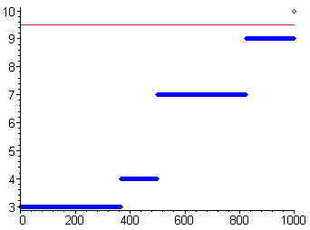
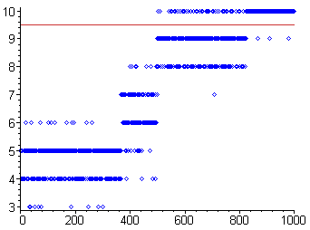
Figure 9: Number of colours used while colouring a triangle lattice with the sweeping with deleting and the random order.
Here the horizontal axis denotes the single graphs (1000 pieces) and the vertical axis denotes the number of colours used. For every graph we have a value (a point in the figure), that means the number of colours used by the algorithm with sweeping with deletion and with random order, respectively
The results on the other classes of interference graphs were similar to these, independently of the classes. Let us see for example a test on 1000 graphs from the square lattice class with all the 32 algorithms. Our graphs consist of 30 vertices placed in 6*5=30 squares of side 1, the critical distance moves from 1 to 2. In then next table we can see the average number of colours used and the number of improvements needed.

Average number of colours used | Random |  | Deleting |  | Degree |  | Global
Average number of colours used | Gr. | Cl. | Gr. | Cl. | Gr. | Cl. | Gr. | Cl.
Simple | 5.368 | 5.252 | 4.680 | 4.677 | 4.867 | 4.789 | 4.712 | 4.709
Improving | 4.907 | 4.866 | 4.674 | 4.673 | 4.723 | 4.714 | 4.692 | 4.691
Number of improve-ments | 1282 | 1007 | 12 | 9 | 385 | 241 | 32 | 28

Average number of colours used | Breadth |  | Depth |  | Deglocal |  | Dellocal
Average number of colours used | Gr. | Cl. | Gr. | Cl. | Gr. | Cl. | Gr. | Cl.
Simple | 4.739 | 4.719 | 4.776 | 4.750 | 4.867 | 4.819 | 4.879 | 4.828
Improving | 4.700 | 4.696 | 4.716 | 4.707 | 4.744 | 4.734 | 4.770 | 4.752
Number of impove-ments | 57 | 35 | 100 | 66 | 310 | 226 | 230 | 166
Table 2: Results of the tests on the square lattice graph class
The differences between the more sophisticated algorithms are not so important on these interference graphs, but melioration can be obtained. Compared to the simplest algorithm with random sweeping when we know the whole graph, the best algorithm is the „clever improving with deletion”; here the choice of the colour and the role of improving did not prove to be very important. In the local case (satisfying our assumptions), the most effective algorithm was the „breadth clever improving”. Here the choice of colours and the role of improving are perceptible.
We can ask ourselves, why the deleting algorithm turned to be the best for interference graphs. One reason can be that with this algorithm the first vertices to be deleted are those near to the edge of the graph, with small degrees, than we continuously go toward the center of the graph, where we finally find the knots and cliques, which are critical from the point of view of colouring. So when colouring, we begin with the critical vertices, cliques and high-degree vertices, and we finish with those on the edge, easy to colour without the need of improving. The local version of this does not work so well and in that case we need the breadth sweeping, which assumes more communication between the base stations.

Summary
We managed to create algorithms, which give results approximating the optimum expectedly well – in general and in reality - under the given conditions, simply and quickly. On the other hand, we should keep in mind when choosing an algorithm that we have to pay the price for both the technological solutions at the base stations, and the communication between them. For this reason, a simpler, cheaper but less efficient version may be more advantageous for the real implementation.
We mention a possible further development of the subject. Since radio waves travel in the three-dimensional space, the interference graphs can be naturally imagined in space, which gives a new dimension to the research of the above problem in the strict sense of the word.

Our grateful acknowledgements are due to András Rácz (Traffic Lab. Ericsson) who was of great help to us as a tutor for two years.

References
- P. Biró, K. Lója, M. Sütő. Elosztott frekvencia-kiosztási algoritmusok tervezése és vizsgálata. (a work for the Scientific Students Associations Conference) http//:www.math.bme.hu/~biro/tdk
- Bollobás B. The chromatic number of random graphs Combinatorica, vol. 8, 49-55, (1988).
- C. A. Christen, S. M. Selkow. Some perfect colouring properties of graphs. J. Combin. Theory Ser. B 27, 49-59 (1979).
- R. Graham, M. Grötschel, L. Lovász. Handbook of Combinatorics, chapter 4 (1995).
- T. R. Jensen, B. Toft. Graph Coloring Problems John Wiley and Sons, New York, (1995).
- L. Lovász, M. Saks, W. T. Trotter. An on-line graph coloring algorithm with sublinear performance ratio. Discrete Math. 75, 319-325, (1989).
- R. A. Murphey, P. M. Pardalos, M. G. C. Resende. Frequency assignment problems. Handbook of Combinatorial Optimalization, Kluwer Academic Publishers, (1999).

